Directional Flow
Desktop publishing
Focus
White space
Alignment
KIS principle
Symmetrical balance
Letterhead
Asymmetrical balance
Contrast
Z Pattern
Thumbnail sketch
Drop cap
Watermark
Business information set
Repetition
Balance
Proximity
Reverse text
Proportion
Consistency

- _______________________________ Using a personal computer, word processor, graphics editor, and page layout software to design, lay out, and produce a publication electronically

- _______________________________ A miniature draft of the document . . . a sketch

- _______________________________ An element that draws the reader’s eyes

- _______________________________ The background where no text or graphics are located

- _______________________________ Keep It Simple

- _______________________________ Equally distributing the weight of elements on a page

- _______________________________ Similar elements of equal proportion or weight on the left and right sides and top and bottom of a page

- _______________________________ Using different design elements of varying weights and/or proportions to achieve balance

- _______________________________ The difference in the degrees of lightness and darkness on a page

- _______________________________ The pattern that leads the readers’ eyes

- _______________________________ The pattern of reading that draws the eyes from the upper left corner of a page to the right, down to the lower left, and then across to the lower right.

- _______________________________ Uniformity among specific design elements

- _______________________________ Generally described as white text on a black background

- _______________________________ The first letter of the first word in a paragraph, set into the paragraph, often set in a larger type size and contrasting typeface

- _______________________________ A lightened version of an image

- _______________________________ Sizing elements in relation to their relative importance to each other

- _______________________________ Preprinted stationery with facts about a company such as name, address, etc.

- _______________________________ A group of customized information components about an individual or an organization that can be used to generate information text boxes across publications.

- _______________________________ Repeating visual elements of a design through a document

- _______________________________ Aligning elements to achieve a visual connection with other elements on a page

- _______________________________ Items related to each other grouped close together.

Computer Literacy - Vocabulary Review

- Open Microsoft Publisher
- From the Available Templates page, choose Quick Publications; then choose a template to work with
- Save this file right away as Vocab Review
- Go to the Page Design; use a color scheme of your choice; change the background to a color of your choice
- Delete the two text boxes and the picture placeholder (blank box reserved for a picture).
- Duplicate this page 15 times (Insert Tab > Page Button > Duplicate Page)
- Look at your vocabulary lists and pick (12) words that you are struggling with (be honest with yourself and pick difficult words; picking words that you know won’t help you review for this test).
- For all odd numbered pages (see below for example):
  - Use WordArt to create the name of the vocabulary word; you choose the style and color
  - Use the “Draw Text Box” button to create a textbox that has the definition of the word; change the font to Calibri, size 36 pt
  - Go to your Internet Browser to located a picture associated with the vocabulary word
    - The picture can be a picture of what it looks like OR a screen shot image of where you go to work with the vocabulary word (i.e. bookmarks, hyperlinks)
- For all even numbered pages (see below for example):
  - Insert Tab > Page Parts > Choose a sidebar or story page part that includes a picture, place for title, and place for description
  - Insert your vocabulary word in place of the title
  - Insert the definition in the proper place for the description (change the font size to 28pt)
  - Click on the picture and replace it (Format Tab > Change Picture) with a picture associated with that vocabulary word
- Resave

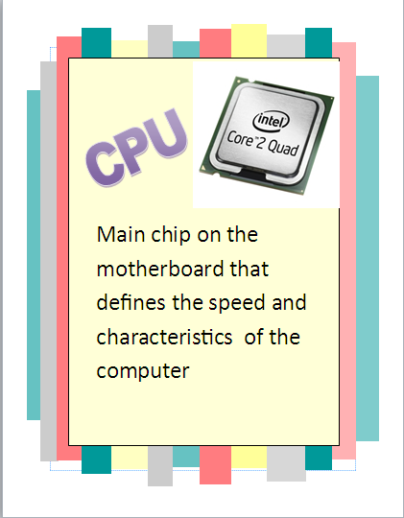
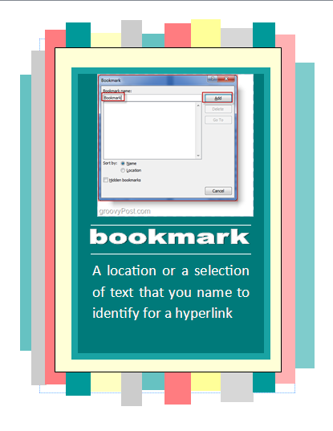
Odd Numbered Pages (Layout) Even Numbered Pages (Layout)

