Desktop Publishing Name___________________________________________

Part A Matching Terms and Definitions
A. Alignment  B. Asymmetrical balance  C. Balance  D. Business information set  E. Consistence  F. Contrast  G. Desktop publishing  H. Directional Flow  I. Drop cap  J. Focus  K. KIS principle  L. Letterhead  M. Proportion  N. Proximity  O. Repetition  P. Reverse text  Q. Symmetrical balance  R. Thumbnail sketch  S. Watermark  T. White space  U. Z pattern | 1.________The design element in which items related to each other are grouped close together.  2. ________Utilize uniformity among design elements to achieve this.  3. ________The difference in the degrees of lightness and darkness on a page.  4. ________A miniature draft of a document.  5. ________Preprinted stationery about a company such as name, etc.  6. ________Using a personal computer and page layout software to design, layout.  7. ________A design principle in which you align elements to achieve a visual connection with other elements on a page.  8. ________The pattern that leads the readers’ eyes on a document.  9. ________ A lightened version of an image usually placed as a layer behind text.  10. ________The principle that stresses to keep design simple.  11. ________An element that draws the reader’s eyes.  12. ________The background where no text or graphics are located.  13. ________Equally distributing the weight of elements on a page.  14. ________The first letter of the first word in a paragraph, set into the paragraph, often set in a larger type size and contrasting typeface.  15. ________White text on a black background  16. ________The element in which you repeat visual elements of a design through a document.  17. ________The pattern of reading that draws the eyes from the upper left corner of a page to the right, down to the lower left, and across to the lower right.  18. ________Similar elements of equal proportion or weight on the left and right sides and top and bottom of a page.  19. ________Sizing elements in relation to their relative importance to each other.  20. ________Using different design elements of varying weights and/or proportions to achieve balance.
Part B True or False

- _______The most important goal in desktop publishing is to get the message across.
- _______Larger elements such as titles and some graphics are generally viewed as less important.
- _______Readers are more likely to read a page where all the elements are in proportion to one another.
- _______Contrast can be used as an organizational aid so readers can identify the organization of the document.
- _______Limited white space creates a more open and light feeling on a page.
- _______Color is an element that will not elicit a response.
- _______A good designer continually asks questions, pays attention to details, and makes well-thought-out decisions.
- _______Overdesigning is one of the most common tendencies of beginning desktop publishers.
- _______Contemporary design favors symmetrical balance.
- _______Symmetrical design is more flexible and visually stimulating than asymmetrical design.
- _______The principle of contrast states that if two items are not exactly the same, then make them very different.
- _______A reader should be able to glance at a document and instantly understand what’s going on.
- _______A centered alignment is the most common alignment that beginners use as it’s very safe and comfortable.
- _______Proximity doesn’t mean that elements have to be placed together; they must be visually connected in some way.
- _______Nothing should be placed on a page arbitrarily or randomly.
- _______The basic purpose of alignment is to create an interest in the page.

Part C Completion
- The desktop publishing process begins with two steps. Identify the steps.

- Name two advantages of in-house desktop publishing.

- Identify at least five graphic elements that help to create focus.

- There are four steps involved in planning a publication. List them.

- What is meant by prioritizing information in a publication?

Use the image to the left to answer the following questions:
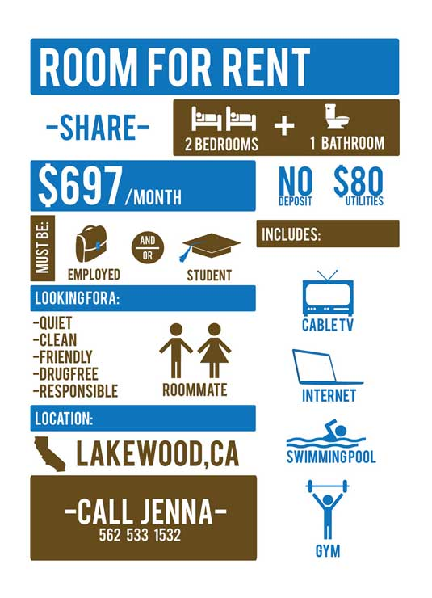
- List two examples of where you see contrast on the flyer shown.

- Identify two examples of repetition used in the flyer shown.

- How was proximity achieved on the flyer shown above? List two examples.

- Provide two examples of alignment on the flyer shown above.

- Identify two ways that were used to provide focus on the example shown above.

