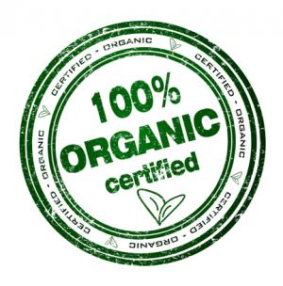
- What are food additives and what are they used for?

- What is Aspartame and what can you find it in?

- What is Olestra and what can you find it in?

- Define each of the nutritional claims you see advertised with food:

http://www.cancer.org/healthy/eathealthygetactive/takecontrolofyourweight/understanding-food-labels

- Free:
- Low:
- Lean:
- High:
- Good Source of:
- Reduced:
- Less:
- Light:

- What is the definition of USDA Organic:

- Define each of the terms used in Dating Foods: http://www.webmd.com/a-to-z-guides/features/do-food-expiration-dates-matter

- Sell By:
- Used By or Expiration:
- Freshness Dates:
- Pack Dates:

Food Label #1
Using a food label of your choice, complete the following information. If the food label does not contain a certain piece of information- please write “NA” (not applicable) in the space provided.
Name of product _____________________________________________
Serving size _________________ number of servings _____________ total calories _________________________
Main ingredient in product ______________________________________
Is the product fortified or enriched? If so, with what nutrients?
Common label terms...... check your text for their definitions. Is there an indication that these are used on your label? What nutrients are they referring to?
“High” in any nutrients? If so, which ones?
“Good source” of any nutrients? If so, which ones?
“Reduced” in Calories or any nutrients? Again, if so, which ones?
“Free” in fat, saturated fat, trans fat, sodium, cholesterol or Calories? Once more, which ones?
What benefit does the food offer?
There are three important forms of carbohydrates, two which are listed on labels - sugar (simple, energy source) and fiber (complex, not digested); the third is starch (complex, energy source).
With your label, find the following information about the macronutrients.
Grams of carbohydrate (less dietary fiber) per serving __________
Grams of protein per serving __________
Grams of fat per serving __________
Each of these nutrients supplies energy. Calculate the Caloric content from each nutrient, and then determine the total Calories per serving.
__________ Grams of carbohydrate x 4 Calories/gram = __________ Carb Calories
__________ Grams of protein x 4 Calories/gram = __________ Protein Calories
__________ Grams of fat x 9 Calories/gram = __________ Fat Calories
__________ Total Calories

